COURSE OVERVIEW DE0251(AD6)-4D
Production Operations in the Oil & Gas Fields & Surface Facilities
Operation of Process Equipment, Separation of Oil/Gas/Water, Controlling Flow/Pressure/Temperature, Injection of Water/Gas & Process Troubleshooting

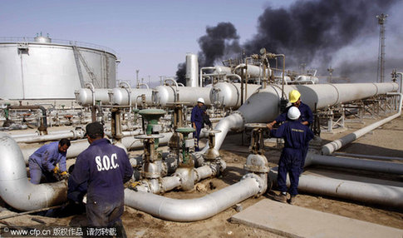
Course Title
Production Operations in the Oil & Gas Fields & Surface Facilities: Operation of Process Equipment, Separation of Oil/Gas/Water, Controlling Flow/Pressure/Temperature, Injection of Water/Gas & Process Troubleshooting

Course Date/Venue

November 25-28, 2024/Al Aziziya Hall, Proud
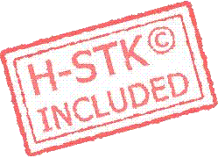
Hotel Al Khobar, Al Khobar, KSA

Course Reference

DE0251(AD6)-4D

Course Duration/Credits

Four days/2.4 CEUs/24 PDHs

Course Description


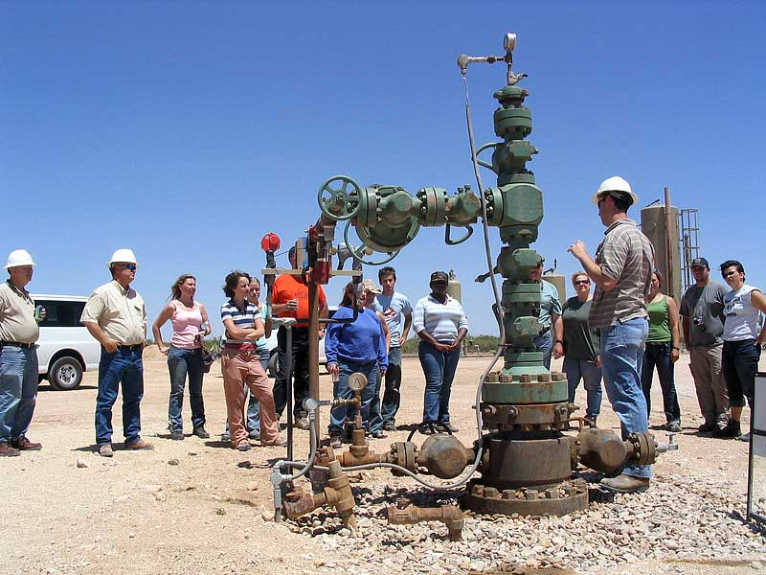
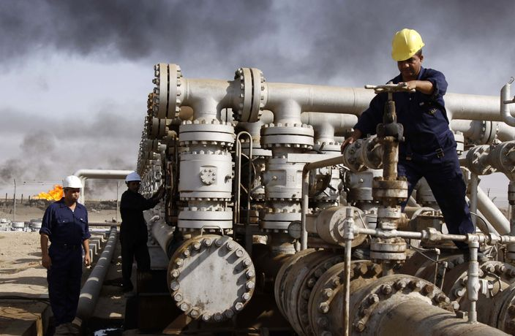
This hands-on, highly-interactive course includes various practical sessions and exercises. Theory learnt will be applied using our state-of-the-art simulators.

This course is designed to provide participants with an up-to-date overview of the production operations in the oil and gas fields and surface facilities covering the operation of process equipment, separation of oil/gas/water, controlling flow/pressure/temperature, injection of water/gas and process troubleshooting. It aims to establish an understanding of the processes, technology, equipment, techniques and HSE associated with oil and gas production and operation.

The course covers the different eras of petroleum industry; the similarities and differences of upstream and downstream O&G; the function, operation and equipment of the wellhead tower; the purpose, equipment and uses of production manifold; the well construction; the vertical, deviated and horizontal wells; the well completion consisting of casing design, fracturing, perforating, acid stimulation, sand control, coiled tubing operations and logging; and the processes involved in the separation of oil, gas and water.

During this interactive course, participants will learn the oil and gas production streams, their flows and pressure; the methods of controlling flow, pressure and temperature; the flow assurance covering paraffin, wax, scale, asphaltenes, corrosion and erosion; the types and purpose of production equipment including the need, operations and equipment of artificial lift; the electrical submersible pumps, gas lift and progressive cavity pumps for heavy oil; the water and gas injection technology; and the proper waterflooding and troubleshooting.

Course Objectives
Upon the successful completion of this course, each participant will be able to:-
- Apply and gain an in-depth knowledge on the operation of process equipment, separation of oil/gas/water, controlling flow/pressure/temperature, injection of water/gas and process troubleshooting
- Differentiate upstream versus downstream O&G and discuss the function, operation and equipment of the wellhead tower
- Recognize the purpose, equipment and uses of production manifold
- Illustrate well construction as well as the vertical, deviated and horizontal wells completion design
- Identify the well completion consisting of casing design, fracturing, perforating, acid stimulation, sand control, coiled tubing operations and logging
- Carryout the processes involved in the separation of oil, gas and water
- Discuss the oil and gas production streams, their flows and pressure
- Employ the methods of controlling flow, pressure and temperature
- Explain flow assurance covering paraffin, wax, scale, asphaltenes, corrosion and erosion
- Identify the types and purpose of production equipment including the need, operation and equipment of artificial lift
- Recognize electrical submersible pumps, gas lift and progressive cavity pumps for heavy oil
- Explain water and gas injection technology and employ proper waterflooding and troubleshooting

Exclusive Smart Training Kit - H-STK®
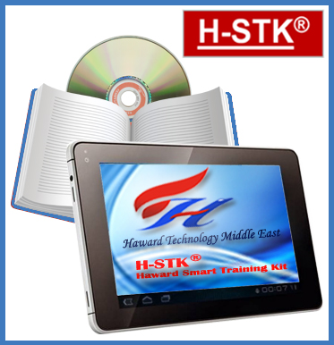
Participants of this course will receive the exclusive “Haward Smart Training Kit” (H-STK®). The H-STK® consists of a comprehensive set of technical content which includes electronic version of the course materials conveniently saved in a Tablet PC.

Who Should Attend
This course provides an overview of the various operations in oil and gas surface production facilities for engineers and other technical staff working in the oil and gas fields. The course is also suitable for engineers and other technical staff who are not working in the oil and gas field but willing to have an introductory knowledge on the subject.

Course Certificate(s)
Internationally recognized certificates will be issued to all participants of the course who completed a minimum of 80% of the total tuition hours.

Certificate Accreditations
Certificates are accredited by the following international accreditation organizations: -
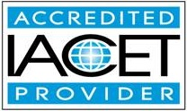
● The International Accreditors for Continuing Education and Training (IACET - USA)

Haward Technology is an Authorized Training Provider by the International Accreditors for Continuing Education and Training (IACET), 2201 Cooperative Way, Suite 600, Herndon, VA 20171, USA. In obtaining this authority, Haward Technology has demonstrated that it complies with the ANSI/IACET 2018-1 Standard which is widely recognized as the standard of good practice internationally. As a result of our Authorized Provider membership status, Haward Technology is authorized to offer IACET CEUs for its programs that qualify under the ANSI/IACET 2018-1 Standard.

Haward Technology’s courses meet the professional certification and continuing education requirements for participants seeking Continuing Education Units (CEUs) in accordance with the rules & regulations of the International Accreditors for Continuing Education & Training (IACET). IACET is an international authority that evaluates programs according to strict, research-based criteria and guidelines. The CEU is an internationally accepted uniform unit of measurement in qualified courses of continuing education.

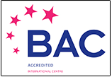
Haward Technology Middle East will award 2.4 CEUs (Continuing Education Units) or 24 PDHs (Professional Development Hours) for participants who completed the total tuition hours of this program. One CEU is equivalent to ten Professional Development Hours (PDHs) or ten contact hours of the participation in and completion of Haward Technology programs. A permanent record of a participant’s involvement and awarding of CEU will be maintained by Haward Technology. Haward Technology will provide a copy of the participant’s CEU and PDH Transcript of Records upon request.
● British Accreditation Council (BAC)

Haward Technology is accredited by the British Accreditation Council for Independent Further and Higher Education as an International Centre. BAC is the British accrediting body responsible for setting standards within independent further and higher education sector in the UK and overseas. As a BAC-accredited international centre, Haward Technology meets all of the international higher education criteria and standards set by BAC.

Course Instructor(s)
This course will be conducted by the following instructor(s). However, we have the right to change the course instructor(s) prior to the course date and inform participants accordingly:


Mr. Konstantin Zorbalas, MSc, BSc, is a Senior Petroleum Engineer & Well Completions Specialist with over 30 years of offshore and onshore experience in the Oil & Gas, Refinery & Petrochemical industries. His wide expertise includes Workovers & Completions, Petroleum Risk & Decision Analysis, Acidizing Application in Sandstone & Carbonate, Well Testing Analysis, Stimulation Operations, Reserves Evaluation, Reservoir Fluid Properties, Reservoir Engineering & Simulation Studies, Reservoir Monitoring, Artificial Lift Design, Gas Operations, Workover/Remedial Operations & Heavy Oil Technology, Applied Water Technology, Oil & Gas Production, X-mas Tree & Wellhead Operations & Testing, Artificial Lift Systems (Gas Lift, ESP, and Rod Pumping), Well Cementing, Production Optimization, Production Operations, Well Completion Design, Sand Control, PLT Correlation, Slickline Operations, Acid Stimulation, Well testing, Production Logging, Project Evaluation & Economic Analysis. Further, he is actively involved in Project Management with special emphasis in production technology and field optimization, performing conceptual studies, economic analysis with risk assessment and field development planning. He is currently the Senior Petroleum Engineer & Consultant of National Oil Company wherein he is involved in the mega-mature fields in the Arabian Gulf, predominantly carbonate reservoirs; designing the acid stimulation treatments with post-drilling rigless operations; utilizing CT with tractors and DTS systems; and he is responsible for gas production and preparing for reservoir engineering and simulation studies, well testing activities, field and reservoir monitoring, production logging and optimization and well completion design.

During his career life, Mr. Zorbalas worked as a Senior Production Engineer, Well Completion Specialist, Production Manager, Project Manager, Technical Manager, Technical Supervisor & Contracts Manager, Production Engineer, Production Supervisor, Production Technologist, Technical Specialist, Business Development Analyst, Field Production Engineer and Field Engineer. He worked for many world-class oil/gas companies such as ZADCO, ADMA-OPCO, Oilfield International Ltd, Burlington Resources (later acquired by Conoco Phillips), MOBIL E&P, Saudi Aramco, Pluspetrol E&P SA, Wintershall, Taylor Energy, Schlumberger, Rowan Drilling and Yukos EP where he was in-charge of the design and technical analysis of a gas plant with capacity 1.8 billion m3/yr gas. His achievements include boosting oil production 17.2% per year since 1999 using ESP and Gas Lift systems.

Mr. Zorbalas has Master’s and Bachelor’s degree in Petroleum Engineering from the Mississippi State University, USA. Further, he is an SPE Certified Petroleum Engineer, Certified Instructor/Trainer, a Certified Internal Verifier/Assessor/Trainer by the Institute of Leadership & Management (ILM), an active member of the Society of Petroleum Engineers (SPE) and has numerous scientific and technical publications and delivered innumerable training courses, seminars and workshops worldwide.

Training Methodology
All our Courses are including Hands-on Practical Sessions using equipment, State-of-the-Art Simulators, Drawings, Case Studies, Videos and Exercises. The courses include the following training methodologies as a percentage of the total tuition hours:-

30% Lectures
20% Practical Workshops & Work Presentations
30% Hands-on Practical Exercises & Case Studies
20% Simulators (Hardware & Software) & Videos

In an unlikely event, the course instructor may modify the above training methodology before or during the course for technical reasons.

Course Fee
US$ 6,750 per Delegate + VAT. This rate includes H-STK® (Haward Smart Training Kit), buffet lunch, coffee/tea on arrival, morning & afternoon of each day.

Accommodation
Accommodation is not included in the course fees. However, any accommodation required can be arranged at the time of booking.

Course Program
The following program is planned for this course. However, the course instructor(s) may modify this program before or during the course for technical reasons with no prior notice to participants. Nevertheless, the course objectives will always be met:

Day 1: Monday, 25th of November 2024
0730 – 0800 | Registration & Coffee
0800 – 0815 | Welcome & Introduction
0815 – 0830 | PRE-TEST
0830 – 0930 | Introduction to the Petroleum Industry  History of the Different Eras
0930 – 0945 | Break
0945 – 1100 | Upstream versus Downstream O&G  Similarities and Differences
1100 – 1230 | The Function, Operation & Equipment of the Wellhead Tower
1230 – 1245 | Break
1245 – 1420 | Production Manifold  Purpose ● Equipment ● Uses
1420 - 1430 | Recap  Using this Course Overview, the Instructor(s) will Brief Participants about the Topics that were Discussed Today and Advise Them of the Topics to be Discussed Tomorrow
1430 | Lunch & End of Day One

Day 2: Tuesday, 26th of November 2024
0730 – 0930 | Well Construction Overview
0930 – 0945 | Break
0945 – 1045 | Completion Design  Vertical ● Deviated ● Horizontal Wells
1045 – 1230 | Overview of the Well Completion  Casing Design ● Fracturing ● Perforating ● Acid Stimulation ● Sand Control ● Coiled Tubing Operations ● Logging
1230 – 1245 | Break
1245 – 1345 | Separation of Oil, Gas & Water
1345 - 1420 | The Oil & Gas Production Streams, Their Flows & Pressure
1420 - 1430 | Recap  Using this Course Overview, the Instructor(s) will Brief Participants about the Topics that were Discussed Today and Advise Them of the Topics to be Discussed Tomorrow
1430 | Lunch & End of Day Two

Day 3: Wednesday, 27th of November 2024
0730 – 0930 | Methods of Controlling Flow, Pressure & Temperature
0930 – 0945 | Break
0945 – 1015 | Flow Assurance  Paraffin ● Wax ● Scale ● Asphaltenes ● Corrosion ● Erosion
1015 – 1100 | Type & Purpose of Production Equipment
1100 - 1145 | Introduction to Artificial Lift  Need ● Operations ● Equipment
1145 - 1230 | Electrical Submersible Pumps
1230 – 1245 | Break
1245 – 1420 | Gas Lift
1420 - 1430 | Recap  Using this Course Overview, the Instructor(s) will Brief Participants about the Topics that were Discussed Today and Advise Them of the Topics to be Discussed Tomorrow
1430 | Lunch & End of Day Three

Day 4: Thursday, 28th of November 2024
0730 – 0930 | Progressive Cavity Pumps for Heavy Oil
0930 – 0945 | Break
0945 – 1045 | Water & Gas Injection Technology
1045 – 1230 | Waterflooding  Methods ● Equipment ● Processes
1230 – 1245 | Break
1245 – 1345 | Troubleshooting  Process ● Pump Failure Analysis
1345 – 1400 | Course Conclusion  Using this Course Overview, the Instructor(s) will Brief Participants about the Course Topics that were Covered During the Course
1400 – 1415 | POST-TEST
1415 – 1430 | Presentation of Course Certificates
1430 | Lunch & End of Course

Simulator (Hands-on Practical Sessions)

Practical sessions will be organized during the course for delegates to practice the theory learnt. Delegates will be provided with an opportunity to carryout various exercises using our state-of-the-art “Gas Ultrasonic Meter Sizing Tool”, “Liquid Turbine Meter and Control Valve Sizing Tool”, “Liquid Ultrasonic Meter Sizing Tool”, “Orifice Flow Calculator” “Centrifugal Pumps and Troubleshooting Guide 3.0”, “SIM 3300 Centrifugal Compressor”, “CBT on Compressors” and, “Heat Exchanger Tube Layout” simulators.

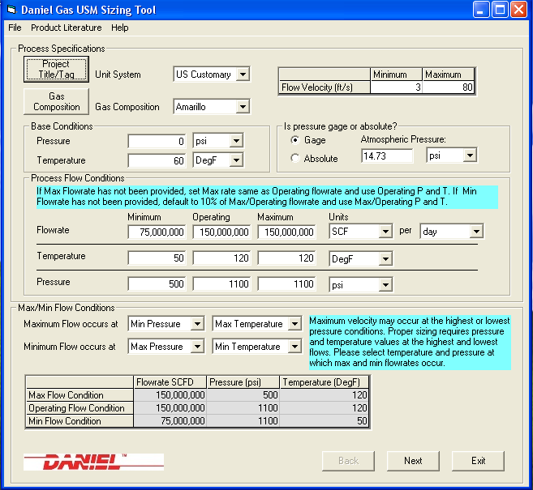
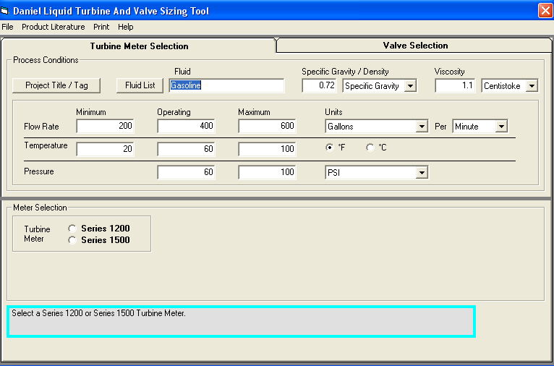

Gas Ultrasonic Meter (USM) Sizing Tool Simulator
Liquid Turbine Meter and Control Valve Sizing Tool Simulator

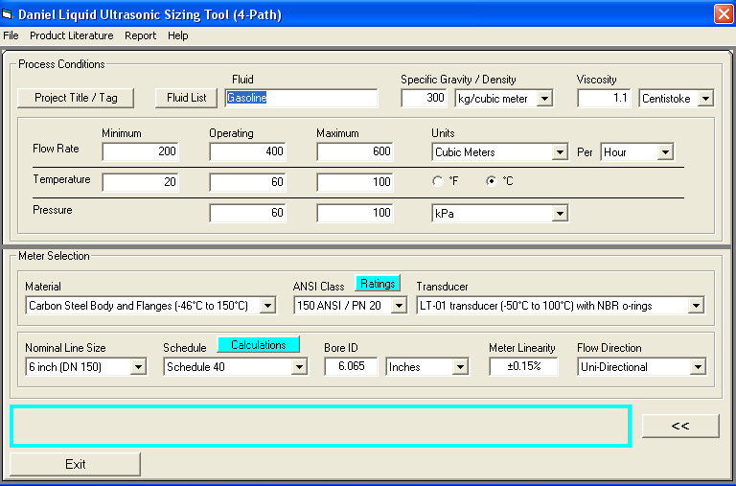
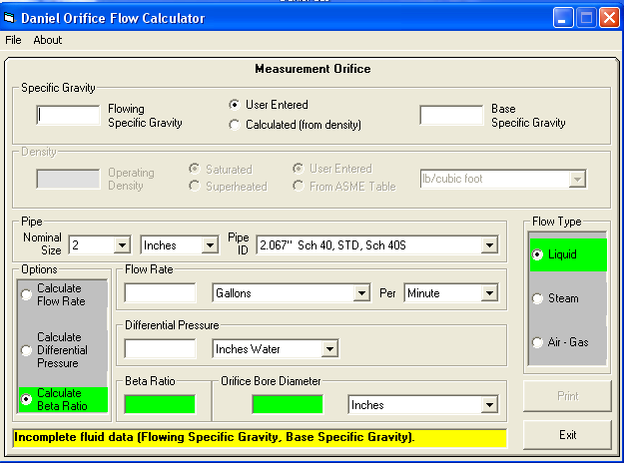

Orifice Flow Calculator Simulator
Liquid Ultrasonic Meter Sizing Tool Simulator

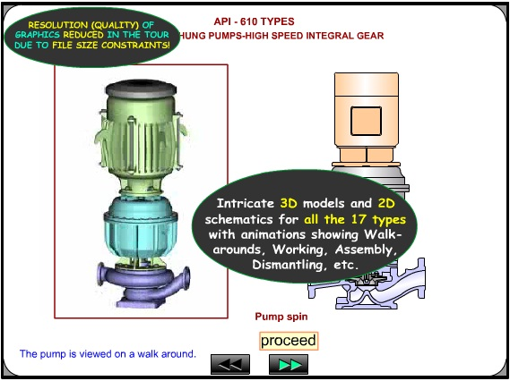
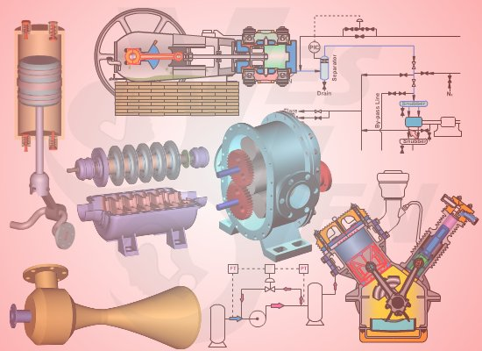
Centrifugal Pumps and Troubleshooting Guide 3.0
CBT on Compressors
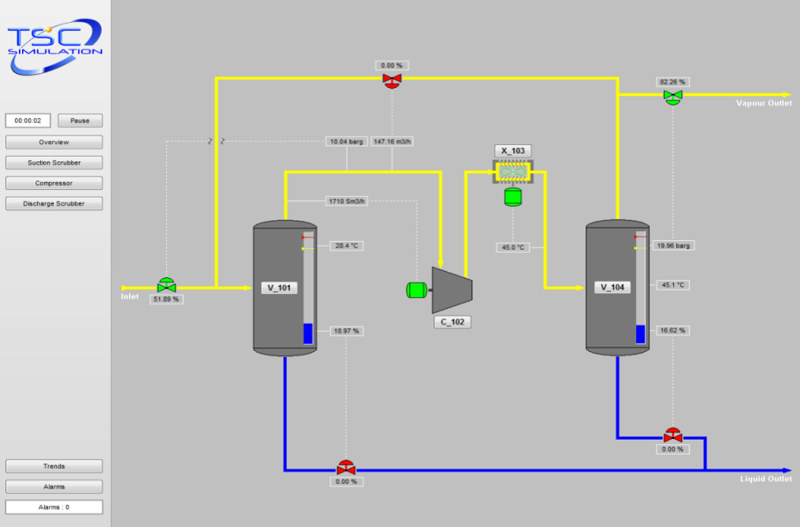

SIM 3300 Centrifugal Compressor Simulator

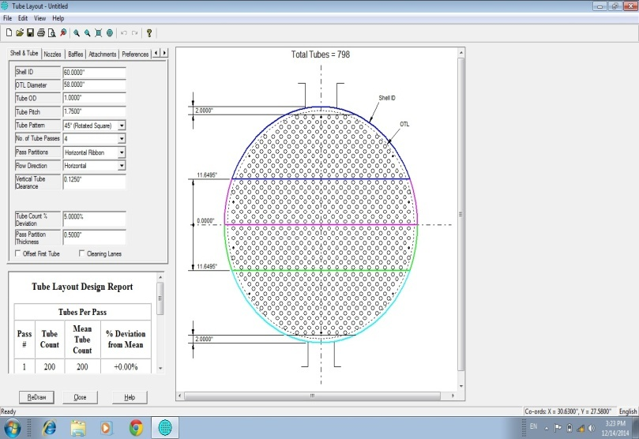
Heat Exchanger Tube Layout Simulator

Course Coordinator
Mari Nakintu, Tel: +971 2 30 91 714, Email: mari1@haward.org

